**Supplemental Information for:**

**Larval Genomics Reveals Cryptic Structure and Climate-Linked Demographic Shifts in Tropical Pacific Tunas**

Jaskiel, J., Aichelman, H.E., Anderson, G., Claassens, L., Fifer, J.E., Hernandez, C.M., Huzar, A.K., Llopiz, J.K., Witting, J.W., Mullen, S.P., Rotjan, R.D.

**Table of Contents:**

|  |  |
| --- | --- |
| **Figure S1.** Preserved larval Thunnus and larval Katsuwonus pelamis | **Page 2** |
| **Table S1.** Summary of Larval and Adult Sampling | **Page 2** |
| **Table S2.** Summary of geographic origin of larval and adult tuna samples | **Page 3** |
| **Table S3.** Summary of SNPs Retained for each analysis | **Page 3** |
| **Figure S2.** Dendrogram of all samples including technical replicates | **Page 4** |
| **Figure S3.** Dendrogram of all samples excluding technical replicates & FST | **Page 4** |
| **Figure S4.** Weighted Pairwise FST across sampling years for each species | **Page 5** |
| **Figure S5.** Average Expected Heterozygosity for each species | **Page 5** |
| **Figure S6.** Average Tajima’s D by chromosome for each species | **Page 5** |
| **Figure S7.** Dendrograms for each individual species cluster | **Page 6** |
| **Figure S8.** Sampling locations of the divergent population of yellowfin | **Page 6** |

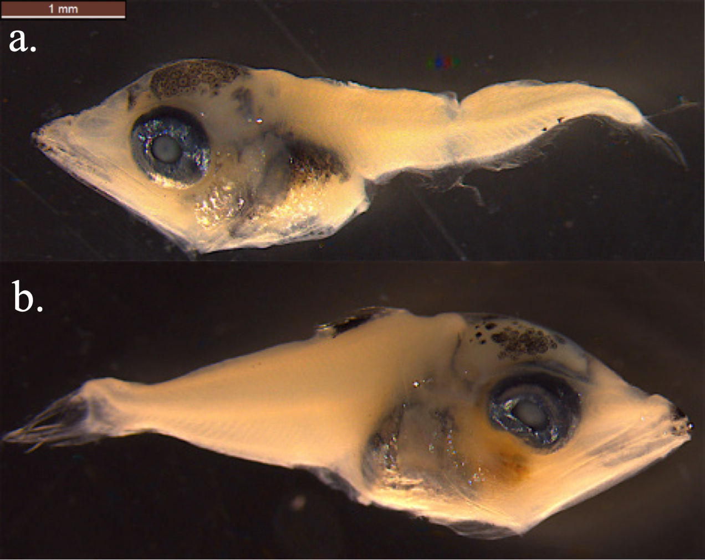

**Figure S1**. Preserved larval *Thunnus* (top) and larval *Katsuwonus pelamis* (bottom)

**Table S1.** Summary of Larval and Adult Sampling (Note: count of total larval *Thunnus* was only possible at genus level using morphological characteristics, and are therefore included as a single number).

|  |  |  |  |  |  |
| --- | --- | --- | --- | --- | --- |
| **Species** | **Total Larvae** | **Larvae Sequenced** | **Total Adults** | **Adults Sequenced** | **Total Tuna Sequenced** |
| *K. pelamis* | 905 | 203 | 0 | 0 | 203 |
| *T. albacares* | 228 | 67 | 30 | 29 | 96 |
| *T. obesus* | 33 | 30 | 24 | 57 |
| *A. thazard* | 8 | 4 | 0 | 0 | 4 |

**Table S2.** Summary of geographic origin of larval and adult tuna samples retained for analysis.

|  |  |  |  |
| --- | --- | --- | --- |
| **Species** | **Phoenix Islands Larvae** | **Phoenix Islands Adults** | **Palau National Marine Sanctuary Larvae** |
| *K. pelamis* | 202 | 0 | 1 |
| *T. albacares* | 61 | 29 | 6 |
| *T. obesus* | 25 | 24 | 8 |
| *A. thazard* | 0 | 0 | 4 |
| Total | 288 | 53 | 19 |

**Table S3.** Summary of SNPs Retained for each Analysis

|  |  |
| --- | --- |
| **Analysis** | **Loci or SNPs Retained** |
| Technical replicate detection (all taxa incl. TRs, “lenient” filters) | 31,694 |
| PCoA, dendrograms, admixture (all taxa excl. TRs, “strict” filters) | 595 |
| Genetic divergence, demographic analysis (Skipjack, LD filtered) | 182,061 |
| Analysis of Genetic Divergence (Yellowfin, LD filtered) | 158,727 |
| Analysis of Genetic Divergence (Bigeye, LD filtered) | 167,089 |
| PCoA, Dendrograms, Admixture (Skipjack, LD filtered) | 334 |
| PCoA, Dendrograms, Admixture (Yellowfin, LD filtered) | 383 |
| PCoA, Dendrograms, Admixture (Bigeye, LD filtered) | 302 |



**Figure S2.** Dendrogram showing hierarchical clustering of pairwise Identity By State values for all samples including technical replicates (N=466) with lenient genotyping filters (31,694 Single Nucleotide Polymorphisms retained) to assist in technical replicate identification.



**Figure S3.** (a) Dendrogram showing hierarchical clustering of pairwise Identity By State values with strict genotyping filters (595 Single Nucleotide Polymorphisms retained) for all samples (N=360) excluding technical replicates. (b) Weighted Pairwise FST between species clusters.



**Figure S4.** Weighted Pairwise FST across sampling years for (a) *K. pelamis*, (b) *T. albacares*, & (c) *T. obesus*.



**Figure S5**. Average Expected Heterozygosity for (a) K. pelamis, (b) T. albacares, & (c) T. obesus. Letters signify statistical significance based on Welch Two Sample t-tests (p < 0.05).



**Figure S6.** Average Tajima’s D calculated across individual chromosomes for (a) *K. pelamis*, (b) *T. albacares*, & (c) *T. obesus*.



**Figure S7.** Dendrogram showing hierarchical clustering of pairwise IBS values for individual species clusters, with indicated number of Single Nucleotide Polymorphisms (SNPs) retained for (a) Skipjack, (b) Yellowfin, and (c) Bigeye.



**Figure S8**. Sampling locations of the divergent population of yellowfin (N=17 larvae). Collections took place on August 9th, 2017; August 9th, 2018; and August 10th, 2018. Inset shows the sampling region in red and Phoenix Islands Protected Area (PIPA) in yellow.